Mount Diablo
A Pearl Harbor Survivor Tradition
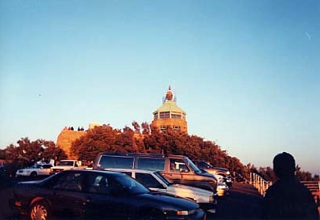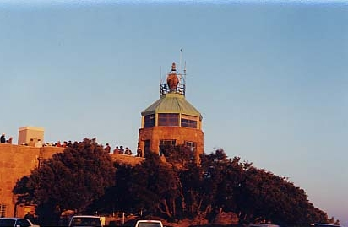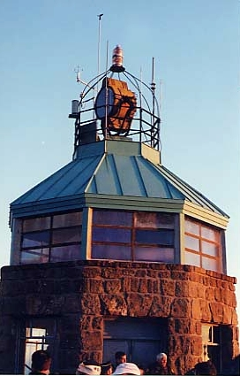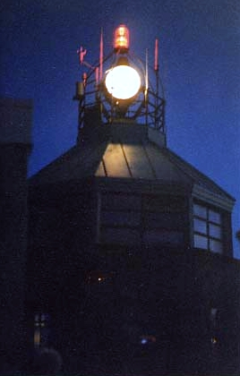 | The lighthouse atop Mount Diablo, in Northern California was built in the early 1900's as an aid to navigation for vessels approaching the entrance to San Francisco Bay. Twenty-six miles inland, it was situated perfectly to provide safe entrance through the dangerous Golden Gate.  On December 7, 1941, the beacon was ordered extinguished and decommissioned to comply with the West Coast blackout ordered after the attack on the Pacific Fleet at Pearl Harbor, Hawaii. Dark it stayed for twenty-three years, the only light being the red aircraft warning light atop the main beacon.  In 1964, San Francisco Bay Area Pearl Harbor Survivors arranged with the California Parks Department to have a beacon lighting ceremony on December 7 of that year. Their intent was to make the drive up the 3,849 foot peak, gather for a rememberance of their fallen shipmates and then to light the beacon at sunset to once again send it's piercing light through the darkness.  The 'survivors' did so, and an annual tradition was launched. Every year since, the group makes the trek, a few members less as their comrades pass on.  This year was no different. A very large group of people joined the 'survivors' at the top. Among these were many veterans, and families that brought their children to witness the event. I sensed it was the largest turnout the park had seen in some time. The formal event began with an invocation and reciting of the Pledge of Allegiance. Opening statements were made and then the remaining Pearl Harbor Survivors were all asked to stand, introduce themself, and state their command. The Danville Chapter, Veteran's of Foreign Wars helped chair the event. The spectators were awed by the short anecdotes a few of the men shared.  At the end, one 'survivor' was asked to turn the switch at sunset and activate the beacon. She lighted immediately and began the 360 degree sweep of the dark skies. The crowd rushed outside to climb to the observation deck for a close up view, or to the parking lot for a longer range vantage point.  The beacon in extinguished at sunrise the following day, to sit still and dark until the next December 7, and once again, the Pearl Harbor Survivors return.
Submitted by: Petty Officer Del Loewe

